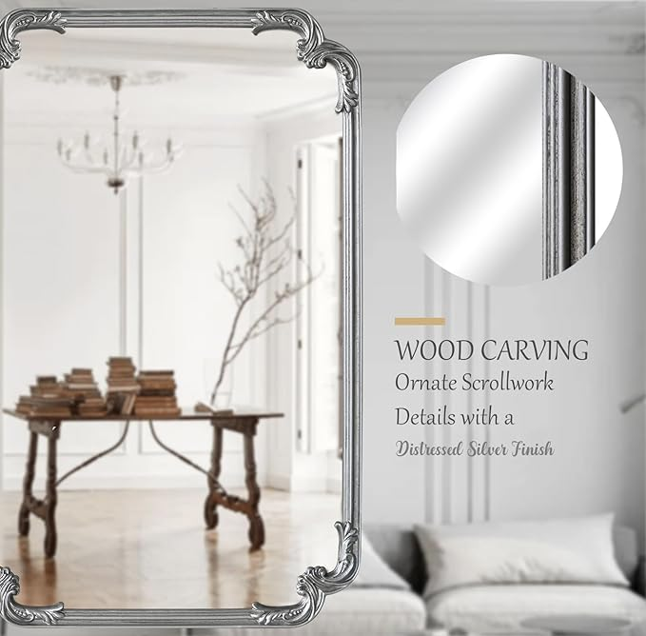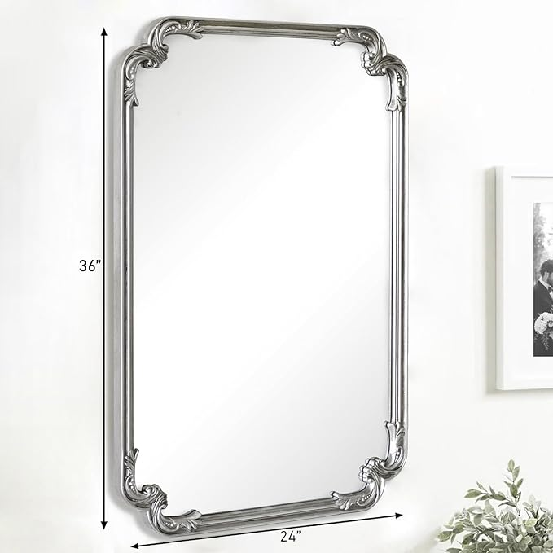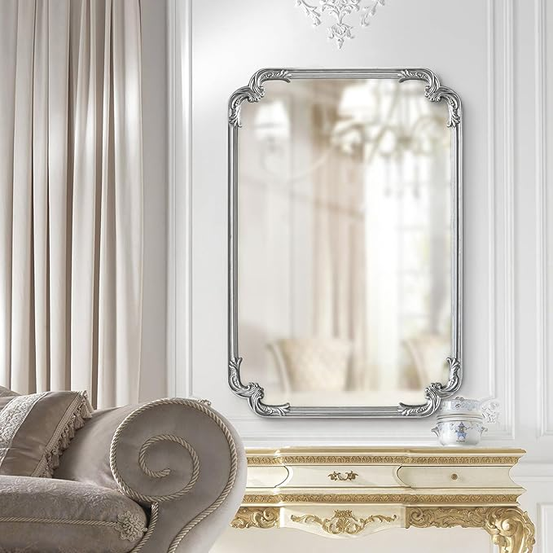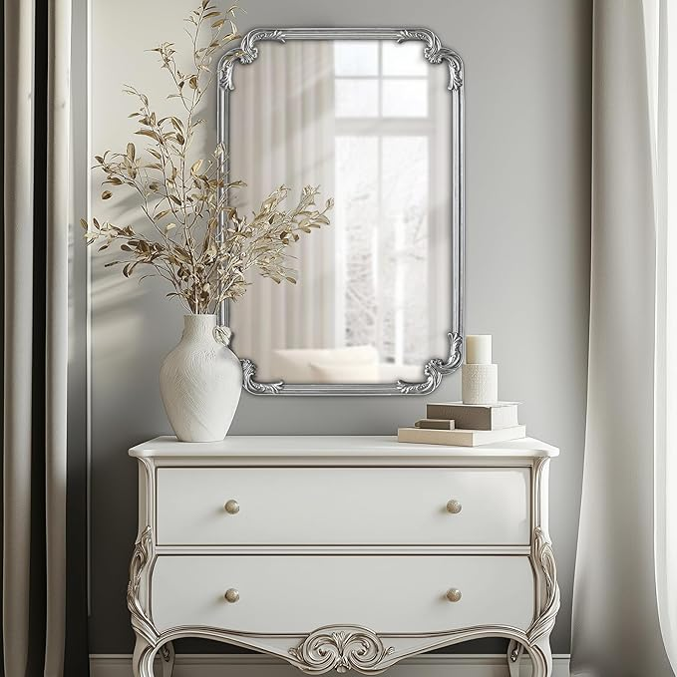

Ornate Wall Mirror, 24" x 36" Silver Decorative Retro Baroque Decorative Antique Vintage Wall Mirror for Living Room Bedroom Fireplace Mantle Entryway

**PRODUCT DESCRIPTION:**

|  |  |
| --- | --- |
| Brand | MOBUDAN |
| Room Type | Bathroom |
| Shape | Rectangular |
| Product Dimensions | 36"L x 24"W |
| Frame Material | Engineered Wood |

**About this item**

* Distressed Silver Frame: The soft, lustrous sheen of the silver complements both classic and contemporary interiors, making it a versatile choice for discerning decorators.
* Exquisite French Style: This French Farmhouse mirror features intricate craving details inspired by classic French aesthetics, this mirror exudes an exquisite charm.
* Versatile Hanging: Choose to hang this mirror vertically to create an elegant statement piece, or horizontally to add a sleek and modern touch to your décor.
* Easy Installation: Mounting this French Style mirror on your wall is a breeze with the included hardware, enabling you to quickly and easily admire its captivating beauty.
* Secure Packaging: The entire mirror is placed inside a high-density foam board and undergoes rigorous drop tests to guarantee the safe delivery of your products.